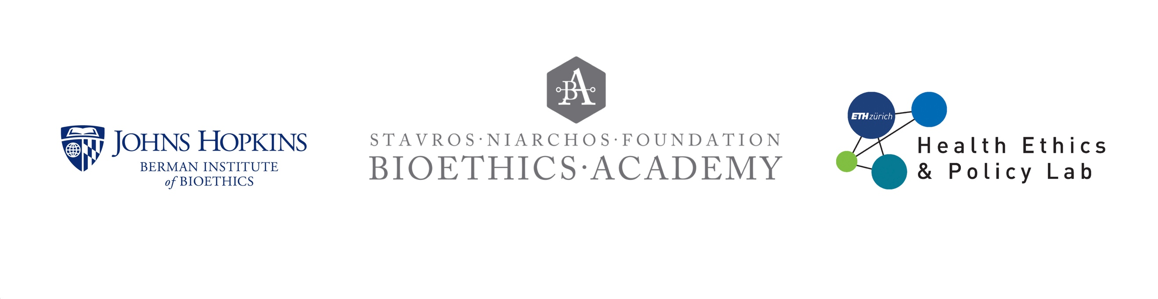

**Case Discussion 3**

**Ethics of randomizing adults to receive different vaccination text message (SMS) “nudges”**

Several studies have been conducted to learn the effectiveness of SMS (text) reminders or messages to encourage vaccination. We discuss here several studies that all share these central features:

* Participants were randomized
* The messages to encourage vaccination were for vaccines that are recommended by public health authorities
* There was neither disclosure nor informed consent letting people know that they were part of a research evaluation and also no disclosure or consent letting them know that they were randomized to receive (or not receive) particular messages related to vaccination

**Study #1:** Patel, Mitesh S., et al. "Effect of Text Message Reminders and Vaccine Reservations on Adherence to a Health System COVID-19 Vaccination Policy: A Randomized Clinical Trial." *JAMA Network Open* 5.7 (2022): e2222116-e2222116.

**In Study #1, employees of a health system were randomized, without their knowledge, to receive one of two different text message reminders to get the Covid vaccination.** As background, in July 2021, this health system instituted a vaccine requirement for all of its employees. Employees were told that they must upload proof of Covid vaccination by November 12, 2021 or risk being terminated from the health system. On a regular basis, verbal announcements were made at in-person meetings reminding employees of this policy and its deadline. Also, email reminders were sent to all employees about every 2 weeks reminding them of the policy and deadline. Vaccination was provided free of charge on-site.

While most employees had uploaded proof of vaccination by September, there remained about 10% of employees who had not provided proof of vaccination. A randomized study was initiated with the goal of increasing adherence to the policy. 2000 employees who had not uploaded proof of vaccination were included in the study sample. Half of them (1000) received text reminders of the vaccine policy. The text reminder included language that a “vaccine is reserved for you” and provided a date when they could receive their vaccine (or they could reschedule to another date). The control group received no text reminders.

**Study #2:** Hofstetter AM, Barrett A, Camargo S, Rosenthal SL, Stockwell MS. Text message reminders for vaccination of adolescents with chronic medical conditions: A randomized clinical trial. Vaccine. 2017 Aug 16;35(35 Pt B):4554-4560. doi: 10.1016/j.vaccine.2017.07.022. Epub 2017 Jul 21. PMID: 28736201.

**In Study #2, adolescents with chronic conditions who had not received highly recommended vaccines were randomized to receive one of two different text message reminders for HPV, influenza, and PPSV vaccinations.** As background, HPV (human papilloma virus) and influenza vaccines are recommended for all adolescents, and PPSV (pneumococcal polysaccharide) is recommended for higher risk adolescents. The need for adolescents with chronic, higher risk conditions to be fully vaccinated is significant given these adolescents’ greater risk of complications should they become infected with one of the diseases these vaccines are designed to prevent. Four primary care clinics participated in this study. Their baseline rates of vaccination for higher risk adolescents ranged from 7% (PPSV) to 65% (influenza). Eligibility included adolescents having visited the clinic in the past 12 months, their parent having a cell phone number on file, the parent speaking English or Spanish, and the adolescent having at least one chronic condition. Most families were low-income, and most spoke Spanish as their primary language.

A randomized study was conducted whereby the parents of eligible adolescents received weekly text reminders that were either “plain” (reminding the parent that the adolescent needed the vaccine) or “educational” (providing information about the purpose and safety of the vaccine and that it was recommended by physicians). Vaccine systems were checked before sending each reminder and were not sent if an adolescent had received the vaccination by the time the reminder was scheduled to be sent.

**Questions:**

1. If you were on the ethics review committee, would you allow either or both of these studies to be conducted without informed consent? What are the reasons to require or to waive consent in this type of study? What characteristics of the study are relevant to you in making the decision?
2. These studies are different in that one had a “no intervention” control (the control group received no text messages) and in the second study both groups received text messages, but the content of the messages was different. Does that matter to your assessment of the ethics of waiving or requiring consent?
3. Consider a similar study conducted to test different text messages meant to encourage vaccination for COVID-19, but administered at a national-level, with the encouragement of Ministry of Health officials and in coordination with Mobile Network Operators (MNOs) to obtain active mobile phone numbers of a sample of 100,000 citizens who appeared to not have been vaccinated according to a national vaccination registry. Would your consent expectations change under such a scenario?