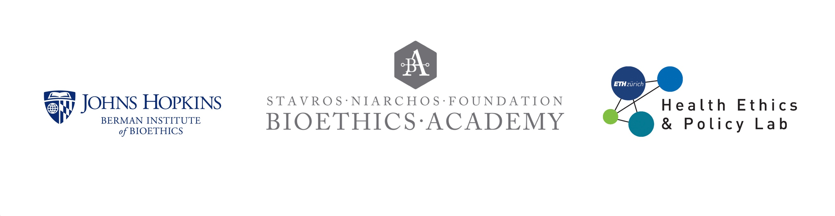

**Case Discussion 4**

**Identifying secondary findings in a parent after prenatal exome sequencing in research[1]**

A 31-year-old patient who was pregnant for the first time underwent a second-trimester ultrasound, which revealed serious anomalies in the fetus that often lead to a significant proportion of stillbirths or deaths early in infancy. Genetic testing of the fetus did not detect any chromosomal abnormalities, and more detailed genetic sequencing was not performed. In the 20th week of pregnancy, the patient chose to terminate the pregnancy through induced labor. An autopsy of the fetus confirmed the ultrasound findings but did not reveal the cause of the anomalies.

The patient and their partner were offered the opportunity to participate in a research study that offered exome sequencing of each of the parents and the fetus in pregnancies diagnosed with structural anomalies and normal standard genetic testing results. In discussing whether to enroll, the couple expressed a desire to find “something identifiable” in the hope that they could then learn the chance of recurrence and whether there would be potential prenatal testing options in future pregnancies. The couple and the fetus each underwent exome sequencing as part of the study.

The research did not identify a known molecular cause of the fetal condition. However, a variant in the BRIP1 gene, which indicates a predisposition to ovarian cancer, was identified in the maternal sample. That result was disclosed to the patient. This disclosure was consistent with the informed consent process, in which the couple was informed that medically actionable findings would be shared.

The patient reported a family history of ovarian cancer in a maternal aunt. She was counseled not to delay reproduction and informed of the potential benefits of bilateral oophorectomy (removal of both ovaries) after childbearing was complete. She was referred to a cancer geneticist for medical management. In the follow‐up interview, the patient reported she was grateful for the knowledge and reported no regrets about having exome sequencing through the research study, and felt strongly that it was the right decision.

Ethics questions for discussion:

1. Does this case raise any ethical issues related to recruitment?
2. What issues does this case raise for the informed consent process?
3. What are the ethical issues raised by secondary findings, such as those discussed in this case? What should be disclosed and to whom?

1. This case is modified from “Case 4” in: Harris S, Gilmore K, Hardisty E, Lyerly AD, Vora NL. Ethical and counseling challenges in prenatal exome sequencing. Prenat Diagn. 2018 Nov;38(12):897-903. doi: 10.1002/pd.5353. Epub 2018 Sep 11. PMID: 30171820; PMCID: PMC6370459. Available at <https://www.ncbi.nlm.nih.gov/pmc/articles/PMC6370459/>