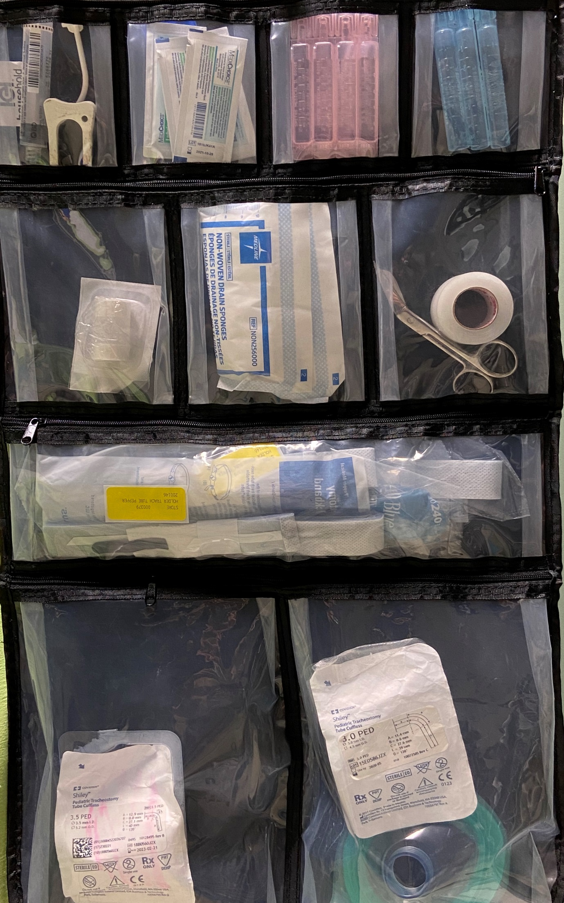

***To***

***Go***

***Bag***

water soluble lubricant

saline

sterile water

downsize trach

resuscitation mask

back up trach

trach ties

Scissors

tape

gauze

HME

syringe

extra obturator

wedge