Is life worse than death? Decision making for children after devastating neurological injury.

Cynda Rushton, PhD, RN, FAAN Emily Johnson, RN, MSN Rev. Matt Norvell, MDiv, BCC
Becky Riggs, MD April Sharp, MD

Background:
J.S. is a 5 year old girl who was found previously healthy, developmentally normal girl was found at the bottom of a family swimming pool during a Labor Day barbecue. She had last been seen by her parents 15 minutes prior to being found. She was not breathing and had no pulse when she was pulled out of the pool. Bystander CPR was initiated immediately. EMS arrived 10 minutes later and obtained return of spontaneous circulation after 15 minutes. Her total downtime was estimated at 25-40 minutes. She was transported to the PICU where she had a GCS of 3T on arrival. Her pupils were fixed and dilated, and she displayed no spontaneous movements. A head CT was obtained as part of the trauma protocol and showed early signs of brain edema. Over the first 24 hours after injury, she was stabilized from a cardiorespiratory standpoint. On hospital day 2 she started taking infrequent, shallow, and irregular breaths over the ventilator. She was monitored for an additional 48 hours without any additional improvement in her neurological exam. Irregular breaths remained the only evidence of brainstem function. A brain MRI was done and showed severe, irreversible hypoxic injury and evidence of brainstem herniation. The PICU and Neurology teams agreed that her injury was irreversible, and that significant recovery was very unlikely. They agreed that she did not meet criteria for brain death due to the irregular breaths. For this child “survival” entails a trach for continued mechanical ventilation and a g-tube for artificial nutrition to support her body in a permanently comatose state.

Questions:
- What therapies should clinicians offer in response to devastating neurologic prognosis in children?
- Are clinicians obligated to provide life-sustaining therapies when neurologic injury is irreversible?
- How do parents’ preferences and faith impact clinical decision making?
- What clinician tools and family resources are available to assist in addressing the ethical challenges that arise in these situations?
Objectives:
- Discuss the clinical decision-making for treatment of children with devastating neurologic injury.
- Explore the ethical boundaries of treatment of irreversible neurologic injury in childhood.
- Examine the role of parental preferences and faith in clinical decision making
- Identify resources for clinicians and families to address ethical concerns.

For more information about future sessions, please go to https://www.bioethics.jhu.edu/efl

The Berman Institute consists of more than 30 faculty from the Johns Hopkins School of Medicine, School of Nursing, Bloomberg School of Public Health, Paul H. Nitze School of Advanced International Studies and the Krieger School of Arts and Sciences. Our mission is to identify and address key ethical issues in science, clinical care, and public health, locally and globally, and our vision is to achieve more ethical practices and policies relevant to human health. To achieve these goals, faculty work collaboratively across the Institute’s program areas: Public Health Ethics, Clinical Ethics, Science Ethics, Research Ethics, and Global Bioethics. The Berman Institute also trains and mentors future leaders in the fields of bioethics, health, and science through the Ph.D. concentration in bioethics and health policy, the Master of Bioethics Program, the Hecht-Levi Fellowship program, the Johns Hopkins-Fogarty African Bioethics Training Program, the Arts and Sciences minor in bioethics, the bioethics certificate, and intensive courses in bioethics.
__________________________________________________________________________________________________
Johns Hopkins Berman Institute of Bioethics
Jeffrey Kahn, PhD, MPH, Director

Joseph Ali, JD
Jean Anderson, MD
Anne Barnhill, PhD
Mary Catherine Beach, MD, MPH
Zackary Berger, MD, PhD
Hilary Bok, PhD
Juli Bollinger, MS
Renee Boss, MD
Angie Boyce, PhD
Joseph Carrese, MD, MPH
Nicole Civita, JD, LLM
Megan Collins, MD
Michael Erdek, MD
Ruth Faden, PhD, MPH
Jessica Fanzo, PhD
Daniel Finkelstein, MD
Norman Fost, MD, MA
Gail Geller, ScD, MHS
Jeremy Greene, MD, PhD
Carlton Haywood, Jr, PhD, MA
Leslie Meltzer Henry, JD, MSc
Mark T. Hughes, MD, MA
Casey Jo Humbyrd, MD
Gail H. Javitt, JD, MPH
Jeff Kahn, PhD, MPH
Nancy Kass, ScD
Carleigh Krubiner, PhD
Michelle Huckaby Lewis, MD, JD
Debra Mathews, PhD, MA
Rebecca McLaren, MD, MPH
Maria W. Merritt, PhD
Margaret Moon, MD, MPH
Jacek Mostwin, MD, PhD
Marie T. Nolan, PhD, MPH
Alan Regenberg, MBE
Travis N. Rieder, PhD
Karen H. Rothenberg, JD, MPA
Leonard Rubenstein, JD
Cynda Hylton Rushton, RN, PhD
Brendan Saloner, PhD
Andrew W. Siegel, JD, PhD
Jeremy Sugarman, MD, MPH, MA
Holly A. Taylor, PhD, MPH
Peter B. Terry, MD, MS
Yoram Unguru, MD, MA, MS
___________________________________________________________________________________________
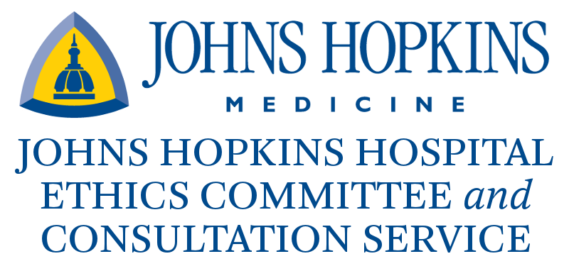
Making decisions about medical care can sometimes be difficult or confusing. When there is uncertainty about what should be done, ethical dilemmas related to values, personal beliefs or religious beliefs can arise. The Johns Hopkins Ethics Committee provides advice to patients, families, surrogates, health care professionals, or other involved parties concerning the complex ethical issues that can arise in the course of patient care.

Who Serves on the Committee? The Johns Hopkins Hospital Medical Ethics Committee and Consultation Service is made up of representatives from various clinical and administrative departments of the Johns Hopkins Medical Institutions, as well as members of the surrounding community. The committee strives to have interdisciplinary representation with physicians, nurses, nurse practitioners, social workers, chaplains, lawyers, administrators, trainees, students, and community members.

What is an Ethics Consultation? Ethics consultations are provided by the Ethics Committee to facilitate discussion among patients, families, health care professionals, and other involved parties faced with concerns or conflict over patient care decisions. These decisions include, but are not limited to: goals of care at the beginning of life and at the end-of-life, decision-making capacity, surrogate decision-making process, organ donation, and medically ineffective treatment. Ethics consultants strive to hear from all parties involved in the care of the patient, in order to understand all of the issues and concerns. The Ethics Consultation team consists of 3-5 committee members from different disciplines, and usually includes a physician, a nurse, a social worker, and a chaplain. Ethics consultations are advisory only; the consultants do not make the decisions for the patients, families, or health care team. Instead, the ethics consultants facilitate discussion regarding the treatment options in any given case, so as to help patients, families and the health care team come to agreement over the ethically permissible options.

How do I contact the Johns Hopkins Hospital Ethics Committee? An ethics consultant can be paged 24 hours a day, 7 days a week. To speak with the ethics consult team leader, a page can be sent via (410) 283-6104. During normal business hours, the Ethics Committee can also be reached by calling (410) 955-0620. The only requirements for requesting an Ethics Consultation are: 1) the patient is being cared for at Johns Hopkins Hospital and/or affiliated outpatient clinics, and 2) the person requesting the consultation is either the patient, a member of the family, the patient’s legal guardian, the patient’s surrogate decision-maker, or a member of the health care team involved in caring for the patient.
__________________________________________________________________________________________________
The Johns Hopkins Hospital Ethics Committee and Consultation Service
Cynda Rushton, RN, PhD, Co-Chair
Mark T. Hughes, MD, MA, Co-Chair

Shannon Barnett, MD
Zachary Berger, MD, PhD
Elaine Bigelow, MD
Sheena Brown
Lourdes Carhuapoma, RN, CRNP
Ty Crowe, MDiv, ACPE
Lee Daugherty Biddison, MD, MPH
Molly Dixon, MPH
Daniel Finkelstein, MD, MA
Margaret Garrett, JD
Nicole Gudzowsky
Peter Hill, MD, MS, FACEP
Nicholas Jabre, MD
Joan Kub, RN, PhD
Pete Linkroum, BSN,RN,OCN,CCRN
Carol Long, RN, CRNP
Tamekia Milton, MDiv
Margaret Moon, MD, MPH
Jacek Mostwin, MD, DPhil
Jeffrey Natterman, JD
Kathryn Neubauer, MD
Matt Norvell, MDiv
Sharon Owens, ACNP-BC, PhD
John V.P.R. Ponnala, MA, BD
Shirley Rawson
April Sharp, MD
Caryl Siems
Amelia Simmons, MSN
Thomas Smith, MD
Alyson Smith-Mitchell, LCSW-C Cathy Stanfield, MBA, MSN, ACNP
Charles (Matt) Stewart, MD
Krista Strantz, LCSW, ACSW, MSW
Peter B. Terry, MD, MA
Pat Triplett, MD
Alison Turnbull, DVM, MPH, PhD
Janice Wallop, MSN, ACNP-BC
Susan Ziegfeld, PhD, ACNP

