Looking Back and Looking Forward 2019

Mark Hughes, MD, MA Amelia Simmons, MSN
Alison Turnbull, DVM, MPH, PhD Zackary Berger, MD, PhD, FACP

Background:
Please join us at the June Ethics for Lunch (EFL) for an interactive session in which we will review topics from the past year and provide an open forum for discussion of topics to consider for the next academic year. We are interested in hearing from the hospital community about the ethical issues that are faced by patients, families, communities, and members of the healthcare team.
The EFL sessions from the past year were:
- The Intersection of Decision-Making Capacity and Mental Illness
- Ethics and the Care of Transgender Patients- Justice/Harm/Respect
- Breastfeeding for US Women with HIV- A Medical and Ethical Analysis
- Issues of Distrust Around Neurological Death, Organ Donation and the Role of Spiritual Care
- Ethical Decision-Making for Patients with Substance Use Disorders Requiring Repeat Cardiac Valve Replacement Surgery
- Ethical Challenges Associated with Enrolling Families in Genetic/Genomic Research
- Informed Consent: When patients Change their Minds
- 26th Annual Shallenberger Lecture “Beyond Charity: Re-Imagined Communities”
- When a Patient’s Refusal of Care Affects the Overall Treatment Plan
Many of the sessions over the past year addressed informed consent. Is the patient capable of making their own decisions? What information needs to be shared with patients and families in order to be adequately informed, especially with diagnostic tests that have uncertain and potentially profound results, as in genetic testing? What should health professionals do when patients or families do not trust the information they are given? Are there decisions that should be taken out of the hands of family members and left to the discretion of the health care team? What about health care decisions that need to be made for patients whose behaviors put their health at risk? How do institutions partner with communities or members of historically underrepresented groups to advance public health and build a culture of respect and trust?
Objectives:
- Define the elements of informed consent and decision-making capacity
- Explore ways to show respect for and support diverse members of the community
- Discuss how to care for patients or families who refuse treatment or disagree with the health care team
- Learn about ethical issues of interest in the hospital community

For more information about future sessions, please go to http://www.bioethicsinstitute.org/efl.
The Berman Institute consists of more than 30 faculty from the Johns Hopkins School of Medicine, School of Nursing, Bloomberg School of Public Health, Paul H. Nitze School of Advanced International Studies and the Krieger School of Arts and Sciences. Our mission is to identify and address key ethical issues in science, clinical care, and public health, locally and globally, and our vision is to achieve more ethical practices and policies relevant to human health. To achieve these goals, faculty work collaboratively across the Institute’s program areas: Public Health Ethics, Clinical Ethics, Science Ethics, Research Ethics, and Global Bioethics. The Berman Institute also trains and mentors future leaders in the fields of bioethics, health, and science through the Ph.D. concentration in bioethics and health policy, the Master of Bioethics Program, the Hecht-Levi Fellowship program, the Johns Hopkins-Fogarty African Bioethics Training Program, the Arts and Sciences minor in bioethics, the bioethics certificate, and intensive courses in bioethics.
__________________________________________________________________________________________________
Johns Hopkins Berman Institute of Bioethics
Jeffrey Kahn, PhD, MPH, Director

Joseph Ali, JD
Jean Anderson, MD
Anne Barnhill, PhD
Mary Catherine Beach, MD, MPH
Zackary Berger, MD, PhD
Hilary Bok, PhD
Juli Bollinger, MS
Renee Boss, MD
Angie Boyce, PhD
Joseph Carrese, MD, MPH
Nicole Civita, JD, LLM
Megan Collins, MD
Michael Erdek, MD
Ruth Faden, PhD, MPH
Jessica Fanzo, PhD
Daniel Finkelstein, MD
Norman Fost, MD, MA
Gail Geller, ScD, MHS
Jeremy Greene, MD, PhD
Carlton Haywood, Jr, PhD, MA
Leslie Meltzer Henry, JD, MSc
Mark T. Hughes, MD, MA
Casey Jo Humbyrd, MD
Gail H. Javitt, JD, MPH
Jeff Kahn, PhD, MPH
Nancy Kass, ScD
Carleigh Krubiner, PhD
Michelle Huckaby Lewis, MD, JD
Debra Mathews, PhD, MA
Rebecca McLaren, MD, MPH
Maria W. Merritt, PhD
Margaret Moon, MD, MPH
Jacek Mostwin, MD, PhD
Marie T. Nolan, PhD, MPH
Alan Regenberg, MBE
Travis N. Rieder, PhD
Karen H. Rothenberg, JD, MPA
Leonard Rubenstein, JD
Cynda Hylton Rushton, RN, PhD
Brendan Saloner, PhD
Andrew W. Siegel, JD, PhD
Jeremy Sugarman, MD, MPH, MA
Holly A. Taylor, PhD, MPH
Peter B. Terry, MD, MS
Yoram Unguru, MD, MA, MS
___________________________________________________________________________________________
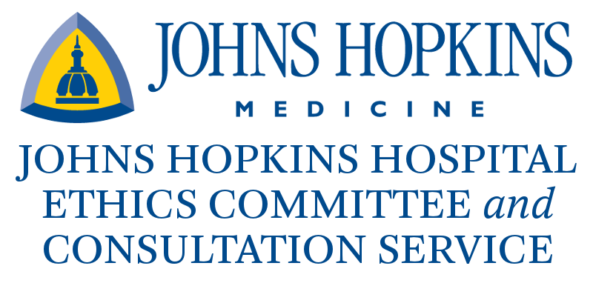
Making decisions about medical care can sometimes be difficult or confusing. When there is uncertainty about what should be done, ethical dilemmas related to values, personal beliefs or religious beliefs can arise. The Johns Hopkins Ethics Committee provides advice to patients, families, surrogates, health care professionals, or other involved parties concerning the complex ethical issues that can arise in the course of patient care.

Who Serves on the Committee? The Johns Hopkins Hospital Medical Ethics Committee and Consultation Service is made up of representatives from various clinical and administrative departments of the Johns Hopkins Medical Institutions, as well as members of the surrounding community. The committee strives to have interdisciplinary representation with physicians, nurses, nurse practitioners, social workers, chaplains, lawyers, administrators, trainees, students, and community members.

What is an Ethics Consultation? Ethics consultations are provided by the Ethics Committee to facilitate discussion among patients, families, health care professionals, and other involved parties faced with concerns or conflict over patient care decisions. These decisions include, but are not limited to: goals of care at the beginning of life and at the end-of-life, decision-making capacity, surrogate decision-making process, organ donation, and medically ineffective treatment. Ethics consultants strive to hear from all parties involved in the care of the patient, in order to understand all of the issues and concerns. The Ethics Consultation team consists of 3-5 committee members from different disciplines, and usually includes a physician, a nurse, a social worker, and a chaplain. Ethics consultations are advisory only; the consultants do not make the decisions for the patients, families, or health care team. Instead, the ethics consultants facilitate discussion regarding the treatment options in any given case, so as to help patients, families and the health care team come to agreement over the ethically permissible options.

How do I contact the Johns Hopkins Hospital Ethics Committee? An ethics consultant can be paged 24 hours a day, 7 days a week. To speak with the ethics consult team leader, a page can be sent via (410) 283-6104. During normal business hours, the Ethics Committee can also be reached by calling (410) 955-0620. The only requirements for requesting an Ethics Consultation are: 1) the patient is being cared for at Johns Hopkins Hospital and/or affiliated outpatient clinics, and 2) the person requesting the consultation is either the patient, a member of the family, the patient’s legal guardian, the patient’s surrogate decision-maker, or a member of the health care team involved in caring for the patient.
__________________________________________________________________________________________________
The Johns Hopkins Hospital Ethics Committee and Consultation Service
Cynda Rushton, RN, PhD, Co-Chair
Mark T. Hughes, MD, MA, Co-Chair

Shannon Barnett, MD
Zachary Berger, MD, PhD
Sheena Brown
Renee Boss, MD
Sheena Brown
Andrew Cameron, MD
Lourdes Carhuapoma, RN, CRNP
Megan Collins, MD
Ty Crowe, MDiv, ACPE
Lee Daugherty Biddison, MD, MPH
Molly Dixon, MPH
Daniel Finkelstein, MD, MA
Margaret Garrett, JD
Nicole Gudzowsky
Peter Hill, MD, MS, FACEP
Joan Kub, RN, PhD
Pete Linkroum, BSN,RN,OCN,CCRN
Carol Long, RN, CRNP
Tamekia Milton, MDiv
Margaret Moon, MD, MPH
Jacek Mostwin, MD, DPhil
Kathryn Neubauer, MD
Marie T. Nolan, PhD, RN
Matt Norvell, MDiv
Sharon Owens, ACNP-BC, PhD
Carrie Price, MLIS, MS
John V.P.R. Ponnala, MA, BD
Shirley Rawson
April Sharp, MD
Caryl Siems
Amelia Simmons, MSN
Thomas Smith, MD
Cathy Stanfield, MBA, MSN, ACNP
Robert D. Stevens, MD, PhD
Charles (Matt) Stewart, MD
Krista Strantz, LCSW, ACSW, MSW
Lode J. Swinnen, MD
Peter B. Terry, MD, MA
Pat Triplett, MD
Alison Turnbull, DVM, MPH, PhD
Susan Vazakas
Janice Wallop, MSN, ACNP-BC
Myrna Weihaus
Jeffrey Zabinski, MD
Susan Ziegfeld, PhD, ACNP

